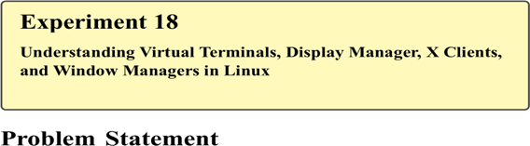

In many real-world applications such as log analysis, report generation, and glossary processing, it is often required to access the last few entries of a file and display them in reverse order. Bash scripting provides support for arrays, which can be effectively used to store file content and manipulate it programmatically.
The problem is to write a shell script that reads the last few lines of a glossary file, stores them in an array, and prints them in reverse order, demonstrating the use of arrays and reverse traversal in Bash scripting.

Theory

Arrays in Bash
An array in Bash can store multiple values indexed numerically. Arrays are useful when dealing with collections of data such as file lines.
Basic array syntax:
array[index]=value
Access all elements:
${array[@]}

Reverse Order Processing
Reverse traversal involves accessing array elements from the last index to the first, which is useful for reversing file content or recent log entries.

Commands Used
tail | Display last lines of a file
read | Read input line
array | Store data in indexed format
for loop | Iterate through array
echo | Display output

Procedure

A. Creating a Glossary File
- Open the terminal.
- Create a glossary file:
nano glossary.txt
- Enter sample content:
Linux: Open-source operating system
Bash: Shell scripting language
Kernel: Core of operating system
File System: Structure for storing data Networking: Communication between systems
- Save and exit the editor.

B. Writing the Shell Script
- Create a script file:
nano reverse_glossary.sh
- Enter the following script:
#!/bin/bash declare -a lines index=0 while read line do
lines[$index]="$line" index=$((index + 1)) done < <(tail -n 5 glossary.txt)

echo "Glossary entries in reverse order:"

for ((i=index-1; i>=0; i--)) do
echo "${lines[$i]}" done
- Save and exit the editor.
- Make the script executable:
chmod +x reverse_glossary.sh

C. Executing the Script
9. Run the script:
./reverse_glossary.sh Sample
